Practical - 6

Task - 1:
Compilation and Execution:
Client.c:
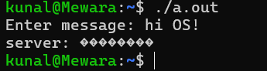
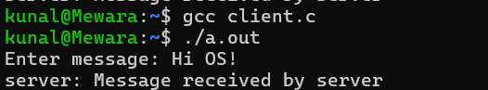

Server.c

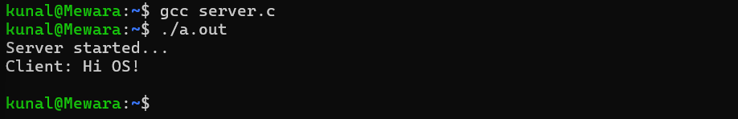

Task - 2:
